Statement of Work

Grainger PLC
Right to Rent - Delivery

Version 2.0
November 11, 2024

Contents
1 Statement of Work 3
1.1 Overview 3
1.2 Solution Overview 3
1.3 Objectives 5
1.4 Delivery Approach 5
1.5 Responsibilities 7
1.6 Availability 8
2 Assumptions, Exclusions & Limitations 9
2.1 Assumptions 9
2.2 Limitations 9
2.3 Exclusions 10
3 Cost and Timelines 11
3.1 Extension of Service Period 12
4 Acceptance 13
5 Appendix A – Reminder Timelines 14

Statement of Work

Overview
Grainger have a legal requirement to check that residential tenants in their English properties have a legal right to rent (RTR).
There is currently limited system functionality to ensure the Tenant Progression Team (TPT) & Renewals follow-up on RTR documentation. At new let, RTR records and corresponding tasks are automatically created in Salesforce, and manually-maintained reminders to follow up on expiring RTR documentation are saved in Qube diaries. There is a heavy reliance on the Renewals Team to follow-up on expired RTR documentation when leases are renewed which adds additional burden to a lengthy and time-sensitive renewals process.
Grainger require a more robust process that is independent of the renewals process, will improve compliance, and provide an audit trail of follow-up activities.
The proposed solution would utilize Salesforce to automatically generate email requests to residents to provide updated documentation and give Onsite Property Managers visibility in residents requiring further follow-up, where necessary.

Solution Overview
The proposed solution would contain the following key features:
- 21 days prior to a RTR expiring, sending an automated email notification and subsequent chaser emails to the resident to provide updated RTR documentation.
- Where a current resident does not provide updated RTR and 12-months has not yet passed since the last RTR check date: Resuming automated chaser emails 60 days prior to the anniversary of the check date.
  - See Appendix A – Reminder Timelines.
- Ability for residents to reply to the email, and for users to see a full history of RTR emails generated to the resident and responses when viewing the RTR record.
  - Email notifications sent to the record owner where a resident responds to a system-generated RTR email or where the system-generated email bounces.
- A new list view that displays RTR records requiring manual follow-up.
- Assigning the relevant Onsite Property Management queue as the record owner for all new and current RTR records.
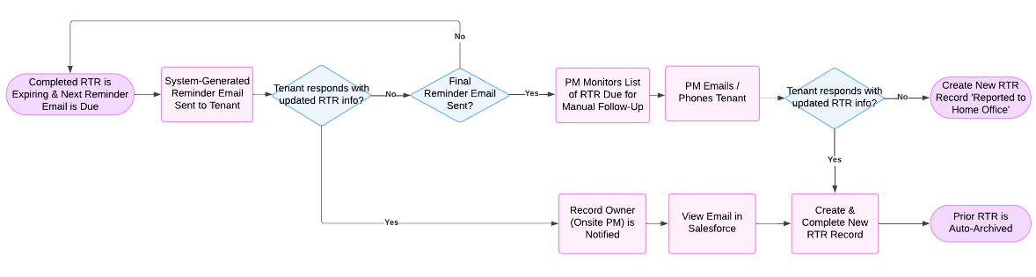
Figure 1: Proposed Process to Manage Expiring RTRs
- On change of sharer (COS) or renewal, only creating new RTR records for any new sharers; and when viewing an opportunity enable users to see any unlimited, un-expired or outstanding RTR records for all residents linked to the opportunity.
- New validation on all opportunities to ensure that a current RTR has been obtained for all tenants prior to sending the lease agreement for signing.
- Additional validation when capturing RTR information to ensure checks for new residents are not completed too far in advance.
- A once-off update to set ‘Completed’ RTR records to a new ‘Vacated’ status (that will not trigger reminder emails) if the tenant is not a current tenant and is not linked to an active opportunity.
  - A list of current tenants will be provided by Grainger, as an Excel data extract from Qube.
- A once-off update to create new RTR records if a current tenant does not have a RTR record in Salesforce.
  - This would be a blank, placeholder record to assist a manual data migration exercise from Qube.
  - A list of current tenants will be provided by Grainger, as an Excel data extract from Qube.
- A data extract to identify existing RTR records that Grainger will need to manually review & update in Salesforce.

Future Functionality
Release 1 will not address the full project backlog. The following functionality may be addressed in future releases:
- Deleting RTR documentation 1 year after a tenant moves out.
- Deleting all RTR information where an opportunity is lost.
- Creation of tasks where a RTR is expiring in order to assist users in tracking RTR requiring follow-up.
- Automatically creating new RTR records where an existing RTR is expiring.
- Automatically closing incomplete RTR records where an opportunity is lost.
- Ability for residents to click on a link in the email and enter their share code and other relevant details, thereby updating the RTR record in Salesforce.
- Possible API integrations to automate the validation of share codes.
- Tenancy status data clean up:
  - A once-off update to activate current tenancy records and end old records.
  - Functionality to automatically keep tenancy status up-to-date.
  - Functionality to save the move out date of a tenant who vacates mid-term.
- Preventing users from creating EOTs for inactive tenancies.

Objectives
The objective of this project is to deliver a solution containing the key features listed in the Solution Overview (excluding future functionality).

Delivery Approach
The delivery approach will be based on the SCRUM framework. Iterative delivery is achieved through a series of 3-week sprints.
An agile delivery approach allows for the early delivery of outcomes and provides flexibility to adjust for any unforeseen opportunities or issues uncovered during the project.
A backlog will be maintained to track outcomes to be delivered and indicate priority of these outcomes relative to each other. The backlog will be a living artifact that will evolve as Open Box and Grainger collaborate towards maximizing the value delivered. Grainger stakeholders will have access to the backlog which will serve as the single source of truth with regards to scope.
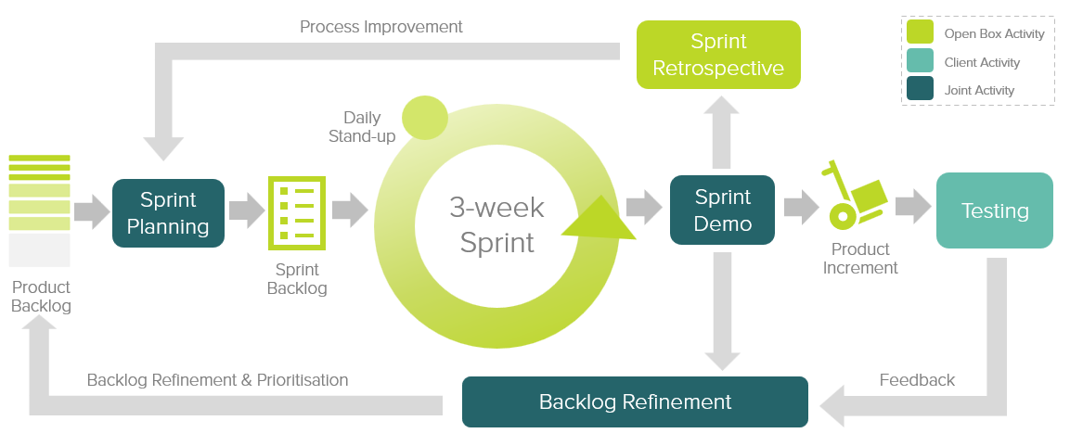
Figure 2: Agile Delivery Approach
Grainger representatives will be required to particulate in the following during each sprint cycle:
- Backlog Refinement – Open Box and Grainger representatives will meet to prioritize use stories on the backlog as well as review and agree on acceptance criteria for user stories at the top of the backlog.
- Demo – Open Box will meet with Grainger representatives to demonstrate the outcomes delivered in the past sprint.
- Sprint Planning – Outcomes on the backlog will be selected for the next sprint.
- Testing – Open Box will be responsible for unit testing and QA testing of all functionality. Grainger representatives will conduct user acceptance testing of new functionality delivered in each sprint and provide feedback withing 1 week of the demo.
- Stand Up – Regular, 15-minute stand-up calls will be held to report on progress; the Grainger product owner is expected to participate in this call to provide feedback and give input on any questions that arise.
Feedback from demos and testing will be classified as either bugs or enhancements (depending on the user story and acceptance criteria). Bugs will be fixed in a subsequent sprint, whereas enhancements will be incorporated into the backlog and prioritized accordingly.

UAT
Designated Grainger business users will be given access to a UAT environment to test the functionality end-to-end and ensure that the overall solution is functioning as expected.
Issues raised will be classified as bugs or enhancements (as above). Bugs will be fixed during the UAT period. Any other enhancements or new requirements will be added to the product backlog for future development.

Support
Open Box will provide post go-live support for 10 working days immediately following the production deployment.

Responsibilities
- Open Box will be responsible for:
  - Providing the services described in the project Objectives.
  - Delivering a progress report to Grainger on a regular basis that will include:
    - General status update
    - Project risks
    - Milestones and timeline
    - Any significant changes to project scope, cost or timeline forecasts.
  - Providing a user guide prior to go-live.
- Grainger will be responsible for:
  - Making an internal product owner available to facilitate decision making.
  - Making key personnel and stakeholders available throughout the project lifecycle, including participation in the activities detailed in the Delivery Approach.
  - Any Salesforce data cleansing required.
  - Delivering any required information or content (e.g. email text and data extracts from Qube) in a timely manner.

Availability
- Open Box resources will be contactable and available for meetings via conference calls:
- Monday to Friday 9am – 6pm South African time (GMT +02:00) which currently corresponds to 8am – 5pm (BST), excluding public holidays.
- A defined escalation path will be provided to the agreed project manager should urgent assistance be required outside of these times.
- All work will be completed by Open Box offsite.

Assumptions, Exclusions & Limitations

Assumptions
- Grainger will provide an Excel extract of current tenants from Qube prior to go-live.
  - The extract will include the Salesforce contact ID, the Qube unit ID (as saved on the Salesforce unit), the Qube tenancy ID.
  - The extract should only include tenants for AST, AST (Affordable), Live Work, or Occupation Contract agreements.
  - Grainger will provide a sample of this extract at the beginning of sprint 1.
- Grainger will provide an Excel extract of current tenants from Qube on a regular (e.g. monthly) basis.
  - The extracts will be in the same format each month.
  - The extracts will include the Salesforce contact ID.

Limitations
- Tenants in Wales will receive the same reminder emails as other tenants.
- As it is not currently possible to identify Grainger Trust units in Salesforce; the system will create RTR records for these new tenants in these units which will need to be manually updated to a ‘RTR Not Required’ status.
- It is not possible to validate that users only select the ‘RTR Not Required’ status for Welsh, DMR or Affordable Rent units.
- The design prompts users to follow up with tenants a specified number of days prior to the next RTR being due. Where a RTR expires prior to this (i.e. prior to the anniversary of the check date), the users will not be prompted to follow up with the tenant prior to expiry of the RTR. See Appendix A – Reminder Timelines.
- If a tenant does not have an email address saved in Salesforce and the RTR expires prior to the anniversary of the check date, the design will only prompt users to follow up with the tenant 60 days prior to the next RTR being due (and not prior to the RTR expiring).
- As it is not currently possible to identify active tenancies in Salesforce, it will not be possible to provide data extracts to assist Grainger in cleaning up permitted occupier data for current tenancies.
- There may be scenarios where a tenant who has vacated (after the last bulk update to ‘Vacate’ RTR records) receives system-generated emails.
- Where a RTR expires less than 60 days prior to the anniversary of the check date, the tenant may receive emails more frequently then the anticipated reminder intervals. See Appendix A – Reminder Timelines.
- Further enhancements to this process may be required if the Rent Reform Bill is enacted.

Exclusions
The following is not included in the cost or scope of this project:
- Data migration (for example migrating existing RTR data in Qube to Salesforce).
- Email template design for emails sent to tenants during the RTR process.
- Solution documentation, other than user stories.
- End-user training or change management, other than provision of a user guide.
- Third-party costs, license fees, subscriptions or services.
- Hardware and infrastructure.
- Possible future functionality detailed above.
- The project cost excludes regular, monthly updates (approximately 1 hour’s effort) to ‘Vacate’ RTR records for tenants who have moved out based on Qube data extracts.

Cost and Timelines
Open Box will provide the following services:
- An agile sprint team delivering sprints at a cost of £23 400 per sprint.
  - Release 1 is currently projected to require 2 sprints (£46 800).
  - The team will be staffed to include the following skillsets as required:
    - Salesforce Architect
    - Business Analyst
    - Developer
    - Quality Assurer
    - Project Manager
- UAT support at a minimum cost of £1 800 per week.
  - Open Box has included 2 weeks (10 working days) cover to be provided to support the UAT process and fix any new bugs identified (£3 600).
  - UAT support will be billed for the duration of the UAT period (i.e., from the end of the final sprint until UAT sign-off by Grainger) on a pro-rata basis.
- Production deployment & and post-go live support at a minimum cost of £1 800 per week.
  - Open Box has included 2 weeks (10 working days) cover to be immediately following the production deployment (£3 600).
The project is estimated to start 11th November 2024.
- The total, remaining project duration is expected to be 8 weeks to deliver release 1 to production, as well as an additional 2 weeks for post go-live support.
- The total cost is estimated to be £66 150 (including sprint 0 which has already been billed).

Project Phases | Remaining Project Duration | Estimate
Sprint 0 (Paid) | Completed | £ 9 000
Sprint 1 - 2 | 6 weeks | £ 46 800
UAT | 2 weeks | £ 3 600
Production Deployment & Post Go-Live Support | 2 weeks | £ 3 600
User guide creation | Done in parallel with sprints | £ 3 150
Total | 10 weeks | £ 66 150

These costs and timelines are forecasts that will be refined at the end of each sprint based on continuous feedback, backlog refinement and re-prioritization.
All amounts are quoted in GBP and exclude VAT, if applicable.
Project costs will be billed monthly, in arrears.
This quotation is valid for 30 days.

Extension of Service Period
The provision of these services may be extended, by mutual agreement between Open Box and Grainger. Email communication is considered sufficient and binding for this purpose.

Acceptance
The parties hereto, each acting under due and proper authority, have executed this Agreement as of the day, month and year first written below.

For and on behalf of Open Box Software For and on behalf of Grainger plc

Signature: _____________________ Signature: _____________________
Name: Sam Duncan Name: Jon Pitt
Position: Salesforce Director Position: Director
Date: _____________________ Date: _____________________

Appendix A – Reminder Timelines
